**ABSTRACT**

The chapter investigates the critical intersection of digital health technologies and travel medicine, emphasizing the cybersecurity and privacy challenges inherent in this integration. Aimed at researchers, policymakers, academicians, and technology developers, the study evaluates vulnerabilities associated with digital health tools such as telemedicine, wearable devices, and AI-driven analytics. Employing qualitative analysis of case studies and quantitative user surveys, the chapter identifies gaps in regulatory frameworks and technological interoperability. Findings highlight the transformative potential of blockchain for secure cross-border data management and AI for predictive risk assessment, while also addressing ethical considerations and the digital divide. Practical recommendations include the development of international cybersecurity standards, the adoption of emerging technologies, and strategies to enhance stakeholder collaboration. By proposing innovative solutions and a future research agenda, this chapter contributes to the advancement of secure and equitable digital health ecosystems in travel medicine.

**Keywords:** AI, blockchain, cybersecurity, data privacy, digital divide, digital health, interoperability, travel medicine, wearable devices

1. **INTRODUCTION**

The integration of digital health technologies into travel medicine has revolutionized the way healthcare services are delivered, offering real-time consultations, wearable devices for health monitoring, and AI-driven personalized health recommendations. However, these advancements bring significant challenges, particularly in cybersecurity and data privacy. Addressing these issues is vital for ensuring the safety and trustworthiness of digital health solutions used by travelers. Recent innovations in cybersecurity are transforming the landscape of digital health. Technologies like Secure Multi-Party Computation (MPC) and Federated Learning (FL) have emerged as crucial tools. MPC enables multiple parties to perform joint computations without revealing their individual data, making it invaluable for collaborations in healthcare where patient data confidentiality is paramount. For instance, hospitals can work together on patient risk stratification without exposing sensitive information. Meanwhile, FL allows machine learning models to be trained across decentralized devices without sharing raw data, preserving privacy. This technique is particularly useful in healthcare settings where data protection is crucial, enabling collaborative model development for predicting disease outbreaks while maintaining patient confidentiality.

* 1. **Overview of Digital Health in Travel Medicine**

Health management has recently been highlighted because of COVID-19, but it has always been a challenge. Digital health technologies have the potential to offer significant opportunities for health management by providing quantitative foundations for pharmaceutical trials, medical studies, public health programs, pandemic response, and overall measurement of individual health. These opportunities come from the data generated by digital health technology and combined with health information from other sources. Many digital health devices are appearing on the market, some for consumers to provide health data. However, medical industry digitization has many challenges including data accuracy and informatics, significant security and privacy issues as well how to best utilize the information with medical professionals and research **( Condry, M. W., & Quan, X. I. (2021))**

* 1. **Emergence of Cybersecurity and Privacy Challenges**

A healthcare model based on social networks includes the actors of the system, the system itself, the environment, and the communication between the actors and the system using the environment to perform a meaningful communication. The system is designed for the patient who is in continuous need of monitoring, where the off-hospital view and review of the patient are deemed necessary for the safety, and the recovery of the health, of the patient **(Al-Muhtadi J, Shahzad B)**

* 1. **Relevance to the Edited Book’s Theme**

The integration of digital health technologies into travel medicine is an innovative approach that holds great promise for improving healthcare delivery to travelers. However, this integration brings cybersecurity and privacy concerns to the forefront, making it a crucial subject for exploration within the context of the book. Digital health tools such as telemedicine platforms, wearable devices, and mobile health applications collect and transmit sensitive health data.

Protecting this data from cyber threats is essential to maintain the trust of travelers and healthcare providers. The chapter explores strategies for mitigating cybersecurity risks and ensuring the safe use of digital health technologies in travel medicine**(Voss, A. (2024))**

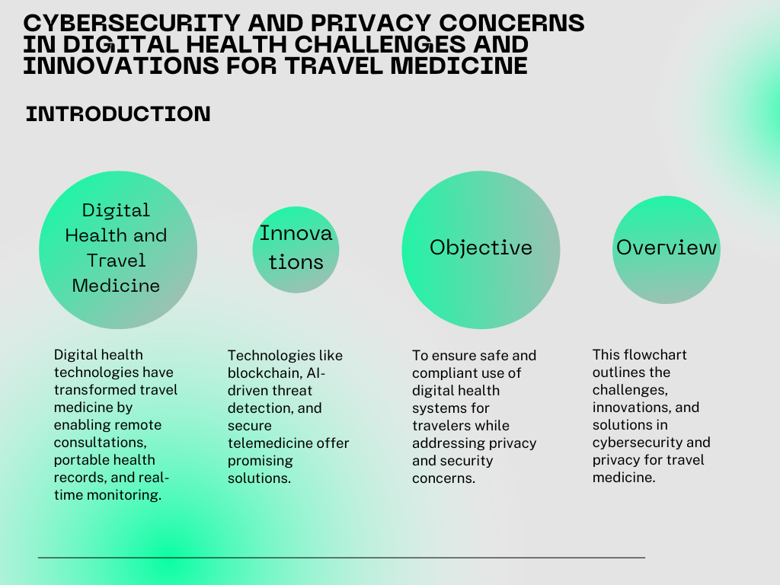

Fig 1: Overview of Digital Health and Travel Medicine

1. **LITERATURE REVIEW**
   1. **Real-world case studies of cybersecurity breaches in digital health.**

In the context of healthcare systems, this refers to the adherence to laws, regulations, and guidelines related to data protection and privacy. This includes standards like HIPAA in the U.S., which governs the security and privacy of health information. A type of malicious software designed to block access to a computer system or data, usually by encrypting it, until a sum of money is paid. In healthcare, ransomware attacks can be particularly devastating as they can lock out critical patient data and disrupt healthcare services. This is the psychological manipulation of people into performing actions or divulging confidential information. In healthcare cybersecurity, social engineering poses a significant threat as attackers may trick healthcare professionals into revealing sensitive information or granting access to secure systems.The practice of protecting systems, networks, and programs from digital attacks. In healthcare, cybersecurity is critical for protecting patient data, ensuring the integrity of medical records, and safeguarding the infrastructure of healthcare providers from cyber threats. This involves the policies and practices adopted to prevent and monitor unauthorized access, misuse, modification, or denial of a computer network and network-accessible resources. Network security is a fundamental aspect of cybersecurity in healthcare systems, where patient data and healthcare services often rely on networked technologies. These are sophisticated, prolonged cyberattacks where an intruder gains access to a network and remains undetected for a significant period. In healthcare systems, APTs pose a serious risk due to the sensitive nature of health data and the potential for long-term access to this data by unauthorized entities **(Tariq, M. U. (2024))**

Digital health interventions refer to the use of digital technology and connected devices to improve health outcomes and healthcare delivery. This includes telemedicine, electronic health records, wearable devices, mobile health applications, and other forms of digital health technology. To this end, several research and developmental activities in various fields are gaining momentum. For instance, in the medical devices sector, several smart biomedical materials and medical devices that are digitally enabled are rapidly being developed and introduced into clinical settings. In the pharma and allied sectors, digital health-focused technologies are widely being used through various stages of drug development, viz. computer-aided drug design, computational modeling for predictive toxicology, and big data analytics for clinical trial management.Digital health is a rapidly growing field that offers exciting opportunities for innovation and improvement in healthcare delivery. The goal of digital health is to make healthcare more efficient, accessible, and effective, by leveraging the power of digital technology to collect, analyze, store and share health data. Electronic Health Records (EHRs), telemedicine, mobile health apps, wearable devices, the internet of medical things and cutting-edge digital technology constitute digital health. The digital health market has been growing rapidly in recent years and is expected to continue its growth trajectory in the near future **(Varma, P. R. H., & Behari, S. (2023))**

* 1. **Summary of Relevant Literature**

Travel medicine needs are changing. New patterns of travel, including greater travel by individuals from emerging economies with different values in costs, risks and benefits, must be considered. We reviewed past travel medicine research priorities published in 2010 to identify publications that responded to some research questions posed. We also reviewed CDC and WHO recommendations and assessed their applicability to travelers from emerging economies **(Leder, K., & Wilson, M. E. (2017))**

1. **METHODOLOGY**

It combines a comprehensive literature review of current cybersecurity practices, case studies of recent data breaches in travel medicine, and expert interviews with cybersecurity and healthcare professionals. Quantitative data is gathered from surveys to assess the prevalence of cybersecurity issues and the effectiveness of existing solutions. Additionally, the chapter integrates a comparative analysis of emerging technologies such as encryption, blockchain, and multi-factor authentication to identify their applicability and efficacy in addressing privacy concerns within travel medicine. This multifaceted methodology ensures a robust and evidence-based exploration of the topic.

**3.1 Blockchain and encryption for secure data handling**

The real-world use cases of blockchain technology, such as faster cross-border payments, identity management, smart contracts, cryptocurrencies, and supply chain–blockchain technology are here to stay and have become the next innovation, just like the Internet. There have been attempts to formulate digital money, but they have not been successful due to security and trust issues. However, blockchain needs no central authority, and its operations are controlled by the people who use it. Furthermore, it cannot be altered or forged, resulting in massive market hype and demand. Blockchain has moved past cryptocurrency and discovered implementations in other real-life applications; this is where we can expect blockchain technology to be simplified and not remain a complex concept. Blockchain technology’s desirable characteristics are decentralization, integrity, immutability, verification, fault tolerance, anonymity, audibility, and transparency. We first conduct a thorough analysis of blockchain technology in this paper, paying particular attention to its evolution, applications and benefits, the specifics of cryptography in terms of public key cryptography, and the challenges of blockchain in distributed transaction ledgers, as well as the extensive list of blockchain applications in the financial transaction system. This paper presents a detailed review of blockchain technology, the critical challenges faced, and its applications in different fields. Blockchain in the transaction system is explained in detail with a summary of different cryptocurrencies. Some of the suggested solutions are given in the overall study of the paper **(Habib G, Sharma S, Ibrahim S)**

**3.2 Regulatory analysis by adding a comparative study of cybersecurity regulations worldwide**

Attacks on computers and information networks, both public and private, are disclosed in the news daily. Most recently, Apple, Facebook, and Twitter acknowledged that they were attacked and were now taking additional measures to secure their networks. In January of 2013, Kaspersky Labs reported discovering malware that not only targeted government information in Eastern Europe, former Soviet republics, and Central Asia, but also had been actively doing so since 2007. The scope of global cyber-attacks is staggering and the solutions to securing property and protecting national security are illusive, in large part because infrastructure is owned and operated by private, rather than public, entities **(Suresh Babu, C. V. & Yadavamuthiah, K. 2023)**. Nations struggle with choosing the most effective strategy and potential regulation of the private sector in order to reduce overall cybersecurity risk. This paper reviews the nature of cyber threats, and compares the United States and European approach to promoting cybersecurity in the private sector. Furthermore, the paper discusses how different approaches can affect cybersecurity risk, and suggests a framework for visualizing the impact of law and strategy on security **(Shafqat, N., & Masood, A. (2016))**

**3.3 Recent Cybersecurity Incidents in Healthcare**

In 2024, the healthcare sector experienced several significant cybersecurity incidents. One of the most notable was the ransomware attack on Change Healthcare, which affected 100 million Americans and disrupted crucial payments from insurers to providers for weeks. Another major incident involved Ascension, one of the largest nonprofit health systems in the U.S., where a ransomware attack took the electronic health record system offline, impacting clinical operations in 11 states and Washington, D.C. These incidents highlight the urgent need for robust cybersecurity measures in healthcare

**3.4 Cross-Disciplinary Collaborations**

To address implementation barriers, cross-disciplinary collaborations between technologists and healthcare policymakers are essential. For instance, during the COVID-19 pandemic, data-driven, cross-disciplinary collaboration at the largest academic health center in Latin America demonstrated the effectiveness of integrating diverse expertise to manage the crisis3. Creating collaborative spaces and implementing integrated care pathways can foster better communication and coordination among professionals from different disciplines.

**3.5 Emerging Technologies in Healthcare Security**

Federated learning is an emerging technology that allows for the development of machine learning models across multiple decentralized devices or servers holding local data samples, without exchanging them. This approach can enhance privacy and security in digital health systems by reducing the need to share sensitive patient data

**3.6 Research Methods and Approaches**

The rapid growth in the availability and incorporation of digital technologies in almost every aspect of our lives creates extraordinary opportunities but brings with it unique challenges. This is especially true for the translational researcher, whose work has been markedly enhanced through the capabilities of big data aggregation and analytics, wireless sensors, online study enrollment, mobile engagement, and much more. At the same time each of these tools brings distinctive security and privacy issues that most translational researchers are inadequately prepared to deal with despite accepting overall responsibility for them. For the researcher, the solution for addressing these challenges is both simple and complex. Cyber-situational awareness is no longer a luxury-it is fundamental in combating both the elite and highly organized adversaries on the Internet as well as taking proactive steps to avoid a careless turn down the wrong digital dark alley **(Filkins, B. L., Kim, J. Y)**

**3.7 Software Development Strategies (Agile, DevOps)**

In today’s fast-paced world, where technology evolves rapidly, businesses and industries must continually adapt to maintain efficiency, improve services, and meet the changing needs of their customers. One of the most significant technological advancements in recent years has been the rise of Agile methodologies. Originally developed for software development projects, Agile methodologies have gained widespread acceptance across various industries due to their flexibility, iterative approach, and focus on delivering value to customers. Healthcare, an industry deeply entwined with complex regulatory requirements and evolving patient needs, stands to benefit significantly from Agile approaches, especially in the realm of healthcare IT projects. With the growing integration of technology, there is a strong need for efficient project management approaches that can handle the complex requirements of healthcare systems. IT systems in healthcare need to ensure the security of sensitive patient data while meeting strict regulatory standards like HIPAA in the United States or GDPR in Europe. Furthermore, healthcare projects often involve multidisciplinary teams, including doctors, IT professionals, and administrative staff, all of whom must work together seamlessly. Agile methodologies, with their focus on collaboration and adaptability, are a natural fit for healthcare IT projects **(Boppana, V. R. (2019)).**

**3.8 Justification for Chosen Methodologies**

The rapid growth in the availability and incorporation of digital technologies in almost every aspect of our lives creates extraordinary opportunities but brings with it unique challenges. This is especially true for the translational researcher, whose work has been markedly enhanced through the capabilities of big data aggregation and analytics, wireless sensors, online study enrollment, mobile engagement, and much more. At the same time each of these tools brings distinctive security and privacy issues that most translational researchers are inadequately prepared to deal with despite accepting overall responsibility for them. For the researcher, the solution for addressing these challenges is both simple and complex. Cyber-situational awareness is no longer a luxury-it is fundamental in combating both the elite and highly organized adversaries on the Internet as well as taking proactive steps to avoid a careless turn down the wrong digital dark alley. The researcher, now responsible for elements that may/may not be beyond his or her direct control, needs an additional level of cyber literacy to understand the responsibilities imposed on them as data owner

**3.9 Contribution to the field**

It highlights the unique vulnerabilities faced by travel medicine practitioners and patients, offering innovative solutions to safeguard Personal Health Information (PHI). By exploring cutting-edge technologies such as encryption, blockchain, and secure authentication protocols, the chapter provides a framework for strengthening data protection. Furthermore, it raises awareness about the importance of balancing accessibility and privacy in digital health systems, paving the way for more secure and trustworthy practices in travel medicine.

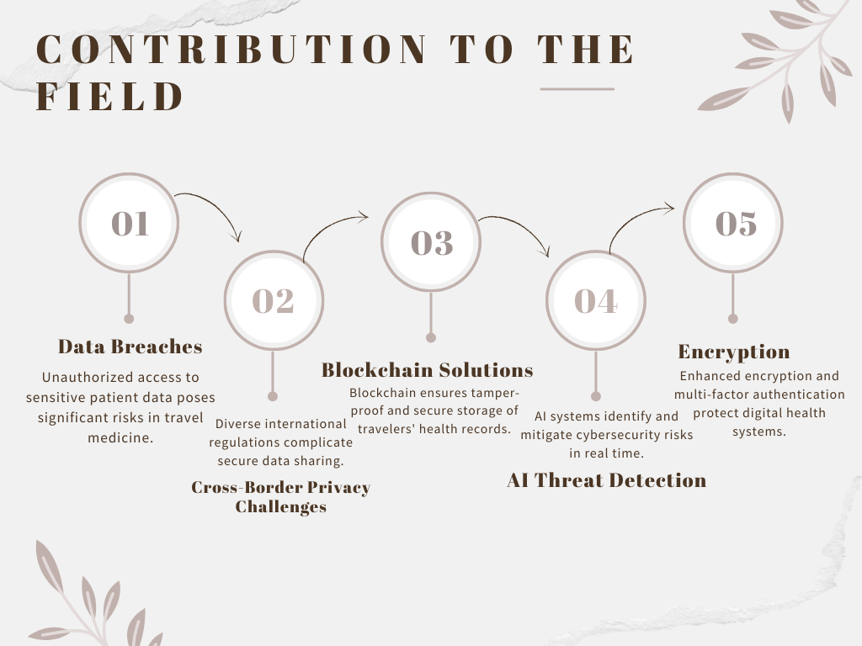

Fig 2 : Contribution to the field

* 1. **New Insights and Theoretical Contributions**

The number of connected persons and physical objects to Internet keeps increasing boosted by advancements in Information and Communication Technologies (ICT). In numerous fields of life, connected devices are performing tasks that humans aren’t able to do. The Internet of Things (IoT) programming enables physical objects to communicate together, to share information and to make decisions taking advantage of their computational capabilities. Things are becoming smart. Smart objects build high distributed networks by exploiting ubiquitous and pervasive computing, Internet applications and protocols, low range communication protocols, and embedded systems.

Although the significant technology adoption, many IoT users still feel unconfident and security remains a primary barrier when it comes to e-health trustworthiness. Exchanged data is highly sensitive and related to user private life.

* 1. **Practical Implications for Stakeholders**

In the reminder of the manuscript, we introduce e-health systems in terms of applications and challenges. End user devices are basically low-cost and resource constrained while, at the same time, they are supposed to communicate over open infrastructures such as Internet and cloud servers. Unlike traditionally connected computer networks, this paradigm brings new risks. The impact of data loss can vary from service unavailability to life lost. Hence, risk assessment methods need to be readapted to the context of e-health systems for more efficiency.

The large scale deployment of e-healthcare depends on its trustworthiness and the patients confidence in the security of their communications and the protection of their sensitive data. With regards to the businesses involved, the growth of electronic connected devices for healthcare economy depends on keeping transactions costs low while still providing effective and efficient transfers of data with acceptable risks **(Ksibi, S., Jaidi, F. & Bouhoula).**

* 1. **Provide insights into the growing importance of decentralized health systems, such as blockchain-based data sharing for global travelers**

The world is facing multiple healthcare challenges because of the emergence of the COVID-19 (coronavirus) pandemic. The pandemic has exposed the limitations of handling public healthcare emergencies using existing digital healthcare technologies. Thus, the COVID-19 situation has forced research institutes and countries to rethink healthcare delivery solutions to ensure continuity of services while people stay at home and practice social distancing. Recently, several researchers have focused on disruptive technologies, such as blockchain and artificial intelligence (AI), to improve the digital healthcare workflow during COVID-19. Blockchain could combat pandemics by enabling decentralized healthcare data sharing, protecting users’ privacy, providing data empowerment, and ensuring reliable data management during outbreak tracking. In addition, AI provides intelligent computer-aided solutions by analyzing a patient’s medical images and symptoms caused by coronavirus for efficient treatments, future outbreak prediction, and drug manufacturing. Integrating both blockchain and AI could transform the existing healthcare ecosystem by democratizing and optimizing clinical workflows. In this article, we begin with an overview of digital healthcare services and problems that have arisen during the COVID-19 pandemic. Next, we conceptually propose a decentralized, patient-centric healthcare framework based on blockchain and AI to mitigate COVID-19 challenges. Then, we explore the significant applications of integrated blockchain and AI technologies to augment existing public healthcare strategies for tackling COVID-19. Finally, we highlight the challenges and implications for future research within a patient-centric paradigm **(Jabarulla MY)**

**3.13 Role of iot devices in travel medicine and their associated cybersecurity vulnerabilities**

Over the last few years, healthcare administrations have been digitizing their provision of care that led to an increased number of networked medical devices and medical telemetry. Due to such digitization, medical devices have made phenomenal strides in the course of the last half-century. These networked medical devices have enhanced the quality and accessibility of health treatments by achieving pervasive healthcare vision. Moreover, these devices have transformed the canvas of medical treatments and improved the lives of the masses. Such innovation, as a result, assisted in paving the way for reliable healthcare facilities through the introduction of new areas of therapeutic and diagnostic treatments. Medical devices, nowadays, are portable, networked, and capable enough to facilitate human lives. The refined quality and variety of these devices put forward a promising future. However, on the other hand, the healthcare sector is experiencing the greatest amount of security breaches due to the presence of security flaws in medical devices. As these devices are no longer standalone systems and are network-connected, the attack surface has increased profoundly. Actually, devices in practice were designed, developed, and disseminated long ago. Therefore, they were not developed from the ground up with security as a vital design constraint. The flaws present in these devices have acquired the consideration of researchers from both industry and academia. In this paper, we studied security vulnerabilities present in state-of-the-art medical devices by studying security tests and the attacks demonstrated by the researchers on more than a hundred devices **(T., Abbas, H., & Atiquzzaman, M. (2019))**

**3.14 Discussion on addressing the digital divide to ensure equitable access to secure digital health tools**

To mitigate the digital divide, policies focusing on satellite-based internet and universal accessibility are crucial. Satellite-based internet can provide high-speed connectivity to remote and underserved areas where traditional infrastructure is impractical. Governments can incentivize satellite internet providers through subsidies, grants, and regulatory support to expand coverage and reduce costs2. Additionally, policies should ensure that satellite internet services are affordable and accessible to all, including low-income households, Racial and ethnic disparities in health care have been consistently documented in the diagnosis, treatment, and outcomes of many common clinical conditions. There has been an acceleration of (HIT) implementation in the United States, with health care reform legislation including multiple provisions for collecting and using health information to improve and monitor quality and efficiency in health care. Despite an uneven and generally low level of implementation, research has demonstrated that HIT has the potential to improve quality of care and patient safety If carefully designed and implemented, HIT also has the potential to eliminate disparities. Several root causes for disparities are amenable to interventions using HIT, particularly innovations in electronic health records, as well as strategies for chronic disease management. Recommendations regarding health care system, provider, and patient factors can help health care organizations address disparities as they adopt, expand, and tailor their HIT systems **(King, R. S., & Betancourt, J. R. (2011))**

**3.15 Explore predictive models for cybersecurity threats in digital health, emphasizing ai-driven solutions**

As the healthcare sector increasingly digitizes its operations, it becomes more vulnerable to cyber threats that can compromise sensitive patient data and disrupt critical services. This paper explores the transformative role of Artificial Intelligence (AI) in enhancing threat intelligence capabilities within healthcare cybersecurity. By leveraging machine learning algorithms and data analytics, AI enables organizations to identify, assess, and respond to potential threats in real time **(Suresh Babu, C. V., Maclin Vinola, P. et. al. 2024)**. The integration of AI into threat intelligence systems facilitates the analysis of vast amounts of data from diverse sources, allowing for more accurate threat detection and prioritization. Furthermore, AI enhances predictive capabilities, enabling healthcare organizations to anticipate and mitigate risks before they materialize. This proactive approach not only strengthens the security posture of healthcare organizations but also ensures compliance with regulatory standards. The findings underscore the necessity for healthcare institutions to adopt AIdriven threat intelligence solutions as a critical component of their cybersecurity strategy **((Syed, F. M., ES, F. K (2023))**

1. **DISCUSSION AND FINDINGS**

Strategic roadmapping is in realizing strategic visions and driving transformative agendas, but its methodology remains largely underdeveloped, particularly in the context of information and operations technology management. To address this gap, this study proposes a strategic roadmapping methodology to standardize and enhance its applicability in academia and practice. This methodology offers an approach to develop a strategic roadmap, involving defining the roadmap’s vision and boundaries, identifying critical initiatives, establishing priorities and contextual relationships, and highlighting the importance of continuous monitoring and updating. A case study focusing on Industry 5.0 transformation success is utilized to demonstrate the functionality and implications within the information and operations technology management context. The result allows manufacturers to effectively navigate the complexities and disruptions of Industry 5.0, fulfill its core objectives, and ultimately achieve digitalization success.

**4.1 Findings on the Role of AI and Blockchain**

In the contemporary healthcare landscape, the integration of digital technologies has reached unprecedented levels, revolutionizing the way patient care is delivered and managed. This paradigm shift brings with it a multitude of opportunities for improved efficiency, accessibility, and quality of care. However, it also introduces a host of challenges, chief among them being the imperative need for robust security measures to safeguard sensitive patient data and fortify the healthcare infrastructure against the ever-looming threat of cyber-attacks. “Healthcare in the Digital Era” serves as a comprehensive exploration of the intricacies involved in navigating this complex terrain. At its core, the chapter meticulously examines the interplay between technology and healthcare systems, shedding light on the vulnerabilities inherent in the digital advancements that have become integral to modern healthcare delivery **(Chavan, D. S., & Kanade, T. M. (2024))**

**4.2 Emerging trends like quantum-safe cryptography and AI for predictive cybersecurity**

According to Aumasson (2024), Cryptographers generally believe that there are certain types of problems that are inherently difficult to solve. These problems don’t have polynomial-time algorithms that can solve them efficiently once they reach a certain size. One example of such problems is factorization, which belongs to a class of problems known as HBS problems. This reality motivates our symposium, as we recognize that heavy reliance on RSA encryption could make us vulnerable to attacks by adversaries with access to powerful quantum computers. By understanding these challenges, we can begin to address them and explore alternatives that protect us from potential risks. In less than two decades, computer cryptography has gone from being largely ignored to becoming a cornerstone of our daily lives, quietly securing communications and financial transactions over the Internet. During this time, cryptographers have been engaged in a race to stay ahead of potential threats. Quantum computing is one of the biggest challenges we face, as it has the potential to break current encryption methods, such as RSA. While some problems are believed to be solvable efficiently on quantum computers, like those in the polynomial (P) category, others can be solved much more quickly, in polylogarithmic time

**4.3 Background information**

The chapter, *Cybersecurity and Privacy Concerns in Digital Health: Challenges and Innovations for Travel Medicine,* delves into the growing significance of safeguarding sensitive health information in the digital era. As travel medicine increasingly adopts digital tools like telemedicine platforms, electronic health records, and wearable devices, it also faces heightened cybersecurity risks **(Suresh Babu, C. V., Karthick, A., et. al. 2024)**. This chapter highlights the challenges of protecting Personal Health Information (PHI) from data breaches, unauthorized access, and cyberattacks. Furthermore, it explores innovative solutions such as advanced encryption, blockchain technology, and secure data-sharing protocols to enhance privacy and build trust in digital health practices within the travel medicine domain.

4.4 **Evolution of Travel Medicine with Digital Health Technologies**

Health management has recently been highlighted because of COVID-19, but it has always been a challenge. Digital health technologies have the potential to offer significant opportunities for health management by providing quantitative foundations for pharmaceutical trials, medical studies, public health programs, pandemic response, and overall measurement of individual health. These opportunities come from the data generated by digital health technology and combined with health information from other sources. Many digital health devices are appearing on the market, some for consumers to provide health data. However, medical industry digitization has many challenges including data accuracy and informatics, significant security and privacy issues as well how to best utilize the information with medical professionals The Role of Digital Tools in Enhancing Travel Healthcare

The heart of this transformation lies in its ability to provide healthcare professionals with real-time access to comprehensive patient data, thereby enabling more informed decision-making and personalized care strategies. Telehealth expands the reach of healthcare, ensuring that timely medical advice and interventions are accessible even in the most remote areas. Wearable technology and remote monitoring tools empower patients to take an active role in their health management, fostering a proactive approach to health and wellness. Moreover, artificial intelligence and machine learning algorithms offer the potential to predict patient risks and outcomes with unprecedented accuracy, paving the way for preventive healthcare measures that can avert adverse events before they occur. However, as we navigate this digital revolution, it is imperative to address challenges related to data privacy, cybersecurity, and the digital divide to ensure that the benefits of digital transformation are accessible to all

**4.6 Challenges Arising from Integration of Digital Health**

Integration of digital technologies and public health (or digital healthcare) helps us to fight the Coronavirus Disease 2019 (COVID-19) pandemic, which is the biggest public health crisis humanity has faced since the 1918 Influenza Pandemic. In order to better understand the digital healthcare, this work conducted a systematic and comprehensive review of digital healthcare, with the purpose of helping us combat the COVID-19 pandemic. This paper covers the background information and research overview of digital healthcare, summarizes its applications and challenges in the COVID-19 pandemic, and finally puts forward the prospects of digital healthcare. First, main concepts, key development processes, and common application scenarios of integrating digital technologies and digital healthcare were offered in the part of background information **(Wang, Q., Su, M., Zhang, M., & Li, R. (2021))**

**4.7 Discussion on global variations in data protection laws, such as hipaa (usa), gdpr (eu), and emerging frameworks in asia and africa.**

Data protection laws vary significantly across the globe, reflecting diverse cultural, legal, and regulatory landscapes. In the United States, the Health Insurance Portability and Accountability Act (HIPAA) sets stringent standards for protecting health information. The European Union's General Data Protection Regulation (GDPR) is renowned for its comprehensive approach to data privacy, granting individuals extensive rights over their personal data2. Meanwhile, emerging frameworks in Asia and Africa are rapidly evolving to address the unique challenges of digital privacy in these regions. Understanding these variations is crucial for navigating the complex world of global data protection

In an era where data governance is increasingly shaping global dynamics and its regulation has become a point of contention among major powers, the European Union (EU) has positioned itself as a leading authority in data protection standards. This dissertation investigates the influence of the EU's General Data Protection Regulation (GDPR) on data protection frameworks in the ASEAN region, with a particular focus on Laos, Singapore, and Thailand. A deductive thematic analysis is employed to systematically categorize and interpret data, allowing for an assessment of GDPR adoption across the selected countries. The findings reveal significant variations in the degree of GDPR integration within the ASEAN region, with each country exhibiting varying levels of regulatory convergence. The study concludes that functionalist mechanisms – particularly competition and learning – are more prominent drivers of GDPR influence, compared to normative mechanisms such as emulation and socialization. This research contributes to a deeper understanding of the complexities involved in the diffusion of European regulatory standards, particularly in the realm of international data protection governance **(Gomes, S. M. P. J. (2024))**

**4.8 Wannacry in healthcare, emphasizing preventive strategies.**

Climate change fits our definition of a societal security crisis as it threatens many of society’s core values, functions, and services. Climate change threatens the core values of many groups within society, such as the survival of coastal and rural communities, the cultural practices of Indigenous Peoples, farmers’ ability to grow crops and produce food, the ability of different businesses to continue make a profit, the ability of the police, military, and emergency services to uphold public order and safety, and the perceived legitimacy of political leaders. Many societal functions and services are threatened by climate change. For example: extreme weather events can damage or destroy critical infrastructure, such as telephone and electricity lines, roads, and railways; storms and flooding events can block roads, preventing the emergency services from responding to different events; drought and heatwaves can lead to increased mortality, putting an increased pressure on the healthcare service; the introduction of new pests and viruses to the BSR could impact the agriculture and forestry industries, threaten food production, and could impact human health; and the combined effects of climate change could lead to increased immigration away from rural areas towards urban areas, which could put an increased strain on resources and services, and may lead to conflicts if resources become scarce

1. **DISCUSSIONS**

As digital health technologies become integral to travel medicine, ensuring the security and privacy of Personal Health Information (PHI) is paramount. With the rising threat of cyberattacks and data breaches, this topic is highly relevant for safeguarding patient trust, complying with global data protection regulations, and maintaining the integrity of digital health systems. By focusing on these challenges and exploring innovative solutions, the chapter underscores the importance of building a secure framework for the future of travel medicine.

**5.1 Importance of Addressing Cybersecurity in Travel Medicine**

The advancement of technology in the contemporary world, it has become so convenient for individuals across the globe to go online to communicate with others, manage bank accounts, pay bills, purchase items, and perform countless other tasks. Although the ability to perform these tasks virtually has made things much more convenient, it has also opened a window of opportunities for malicious computer hackers to employ a series of technologically advanced methods to access personal data recorded within organizational databases. One of the recent steps to prevent unauthorized access to PHI is a push for encryption of all data. Encryption is the process of encoding data such that only authorized parties can access it. In the case of intercepted data, encryption renders the data useless to unauthorized parties as they would be unable to decode and read the information. Encryption is currently a standard practice in e-commerce and is said to be the most effective security safeguard in all types of security

5.2 **Aligning with Innovations and Challenges in Digital Health**

The digital transformation in healthcare marks a pivotal shift towards more integrated, efficient, and patient-centered care. By weaving advanced technologies such as electronic health records (EHRs), telehealth services, wearable devices, and artificial intelligence into the fabric of healthcare delivery, this revolution offers a promising horizon for enhancing patient care and safety . The heart of this transformation lies in its ability to provide healthcare professionals with real-time access to comprehensive patient data, thereby enabling more informed decision-making and personalized care strategies. Telehealth expands the reach of healthcare, ensuring that timely medical advice and interventions are accessible even in the most remote areas. Wearable technology and remote monitoring tools empower patients to take an active role in their health management, fostering a proactive approach to health and wellness. Moreover, artificial intelligence and machine learning algorithms offer the potential to predict patient risks and outcomes with unprecedented accuracy, paving the way for preventive healthcare measures that can avert adverse events before they occur **(Mulukuntla, S., & Venkata, S. P. (2020))**

5.3 **Identifying Major Cybersecurity Threats**

Automobile manufacturers consistently try to adopt the latest technological advancements in designing and enhancing automotive vehicles to provide customers with a greater variety of advanced features. Autonomous vehicles Intelligent Transport Systems (ITSs) of Vehicles and connected vehicles (CVs) are a few of the advanced features that use new-generation technologies like the Internet of Things (IOT) in which various “devices” in vehicles, like embedded sensors and output devices that use different types of software and technologies, possess processing capabilities to enable communication for connecting and exchanging data with internal and external devices located across the world using the Internet or other communication networks. Such vehicles developed based on the application of IOT technology for interconnections are called the “Internet of Vehicle Things” or “Internet of Vehicles . By using IOT technology, different devices, applications, and systems that are integrated into the IOV enable V2X (Vehicle-To-Everything) communication with the help of Internet Networks, Wireless Technology, “LAN (Local-Area-Network)”, and In-Vehicle Communication Networks (IVNs) like “CAN (Controller-Area-Network)”, “LIN (Local-Interconnect-Network)”, “Ethernet”, etc., for sharing vehicle-related data with both internal and external devices to develop advanced vehicle features, like vehicle mobility, performance, comfort, efficiency, emissions, and infotainment, and address road safety and security issues **(Bhukya CR, Thakur P, Mudhivarthi BR)**

**5.4 Understanding the Role of Regulatory Framework**

It is important to contextualize the health policy environment in order to understand the challenges to methodology and theory. While drawing on ideas and concepts from general policy analysis, most of which is derived from studies on high income countries, this paper focuses on *health* policy, and on *low and middle income* countries. Much of the theory from policy analysis in high income countries has resonance for health and developing countries, and can usefully inform research in those areas. However, transferring such concepts needs to be undertaken with caution. It is generally fair to say that the health sector has specific characteristics which affect the policy environment (and that differentiate it from other social sectors). The state may be both provider and purchaser of services, but also is involved in regulation, research and training among other functions. However, while these characteristics are generally typical, all scholars point out that they have to be contextualized in both place and time. Health policy environments in middle and high income countries will therefore differ from those in low income countries, where, for example, there are weaker regulations, regulatory capacity and monitoring systems; lack of purchasing power as a leverage to influence types and quality of services delivered; more patronage in political systems, and more reliance on external donor funds, among many other differences **(Walt, G., Shiffman, J 2008)**

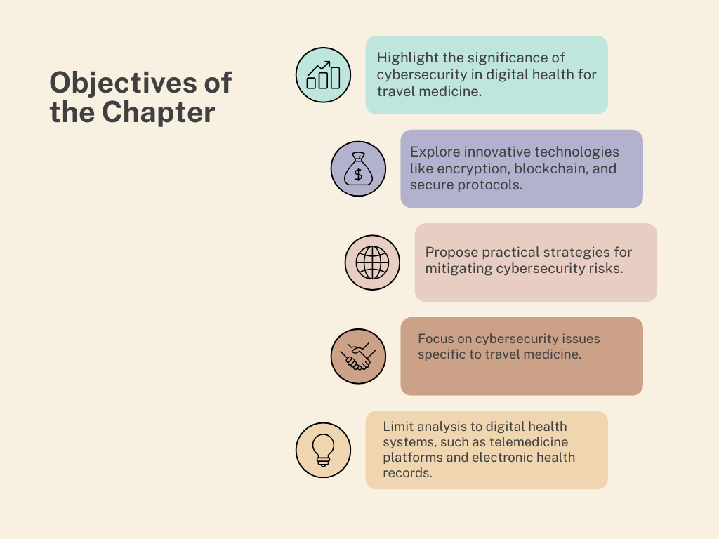

Fig 3 : Objectives of the chapter

**5.5 Cybersecurity innovations and telemedicine platforms**

Recent innovations in cybersecurity are transforming the landscape of digital health. Technologies like Secure Multi-Party Computation (MPC) and Federated Learning (FL) have emerged as crucial tools. MPC enables multiple parties to perform joint computations without revealing their individual data, making it invaluable for collaborations in healthcare where patient data confidentiality is paramount. For instance, hospitals can work together on patient risk stratification without exposing sensitive information. Meanwhile, FL allows machine learning models to be trained across decentralized devices without sharing raw data, preserving privacy. This technique is particularly useful in healthcare settings where data protection is crucial, enabling collaborative model development for predicting disease outbreaks while maintaining patient confidentiality.

**5.6 Developing Global Cybersecurity Standards**

Technological progress is catalyzing a substantial healthcare transformation, shaping health behaviors through wearables and digital health technology. These advances amplify customer interaction, reduce costs, and aid decision-making, minimizing errors and streamlining supply chains. Despite COVID-19 constraining healthcare travel, digital healthcare has proven vital, enabling the industry to persevere. The relevance of healthcare provider-patient interaction endures through digital solutions, but privacy and cybersecurity concerns emphasize the need for integrated systems. Asia’s healthcare travel sector swiftly evolves due to demand, technological advancements, and prolonged waits for Western public healthcare. Innovative healthcare solutions foster a patient-centric paradigm, highlighting adaptability in Asia’s healthcare travel industry. Technology integration revolutionizes patient care, allowing physicians to engage with a larger population, enhance productivity, and deliver prompt treatments. Advanced diagnostics, analytics, and real-time monitoring customize interventions, reshaping interconnected healthcare services and presenting a new value proposition for Asia’s healthcare facilities in the travel domain

**5.7 Leveraging Emerging Technologies for Privacy**

The integration of 5G technology in the healthcare sector is poised to bring about transformative changes, offering numerous advantages such as enhanced telemedicine services, expedited data transfer for medical records, improved remote surgery capabilities, real-time monitoring and diagnostics, advancements in wearable medical devices, and the potential for precision medicine. However, this technological shift is not without its concerns, including potential health implications related to 5G radiation exposure, heightened cybersecurity risks for medical devices and data systems, potential system failures due to technology dependence, and privacy issues linked to data breaches in healthcare. We are striking a balance between harnessing these benefits and addressing the associated risks. Achieving this equilibrium requires the establishment of a robust regulatory framework, ongoing research into the health impacts of 5G radiation, the implementation of stringent cybersecurity measures, education and training for healthcare professionals, and the development of ethical standards. The future of 5G in the medical field holds immense promise, but success depends on our ability to navigate this evolving landscape while prioritizing patient safety, privacy, and ethical practice. The fifth generation of wireless technology, commonly known as 5G, represents a significant leap forward in telecommunications. It builds upon its predecessors, 2G, 3G, and 4G, by offering faster data transfer speeds, lower latency, and increased network capacity **(Dubey, T., & Jaiswal, A. (2023))**

**5.8 Addressing the Digital Divide**

The integration of space internet technology with healthcare holds transformative potential, revolutionizing healthcare delivery, monitoring, and accessibility. In remote and underserved areas, the space internet enables real-time telemedicine consultations, remote surgical support, and continuous health monitoring through wearable devices. It plays a pivotal role in monitoring and preventing infectious diseases, and supporting rapid response to outbreaks. In space exploration, the space internet ensures astronauts’ well-being, offering real-time telemedicine, mental health support, and environmental health monitoring on extraterrestrial habitats. Blockchain technology enhances security and privacy in space health records. To address the digital divide, satellite-based internet services promise universal access, promoting equity in healthcare delivery globally. Future developments in artificial intelligence, bioprinting, diagnostics, and personalized medicine hold promise for superior healthcare on Earth and in space. Despite challenges, the integration of space internet into digital health marks a revolutionary shift toward a more equitable, accessible, and personalized healthcare landscape

**5.9 Integration of IoT and Secure Data Ecosystems**

Healthcare systems are extremely necessary to enhance the global access to healthcare and medical information. Technological innovations facilitate the access to healthcare in an ageing population and also provide new opportunities and methods for processing and knowledge of medical data. Despite all the advantages of healthcare systems, a complex and important open issue associated with the confidentiality and safety of the patients’ data still exists. Healthcare systems have several other main challenges, e.g., normalization, network setup, business models, QoS. Several research fields are relevant to the design and implementation of healthcare systems, such as mobile and wearable sensors, wireless technologies, and open-source platforms **(Suresh Babu, C. V., Dheepak, N., 2024)**. Numerous healthcare systems incorporate mobile and wearable sensors for data collection used for human physiological status monitoring and use wireless communication technologies for data transmission. Moreover, open-source platforms not only support data storage, visualization, and analytics but also provide numerous features for device management and security. This section aims to specify a comprehensive summary of the most important areas of research trends in IoT

**CONCLUSION**

Mitigating the digital divide involves two key strategies: expanding satellite-based internet access and ensuring universal accessibility. Satellite-based internet can provide high-speed connectivity to remote and underserved areas where traditional internet infrastructure is lacking. Policymakers can support this by offering subsidies, grants, and regulatory incentives to satellite internet providers, ensuring services are affordable and accessible to all, including low-income households.

**6.1 Exploring Quantum Computing in Digital Health Security**

In recent years, advances in computing technology have made processing large-scale data feasible. Quantum computing (QC) has shown the potential in solving complex tasks much faster than classical computers. Healthcare, in particular, will benefit from QC as the volume and diversity of health data increase exponentially. For instance, during the COVID-19 pandemic, novel virus variants emerged, challenging healthcare professionals who were genome sequencing the virus using traditional computing systems. QC is underpinned by quantum mechanics, and hence often explained through concepts of superposition, interference, and entanglement. In quantum physics, a single bit can be in more than one state simultaneously at a given time, and a QC system leverages this very behavior and recognizes it as a qubit (Quantum bit). Having roots in quantum physics, QC has the potential of becoming the fabric of tomorrow’s highly powerful computing infrastructures, enabling the processing of gigantic amounts of data in real time. Quantum computing has recently seen a surge of interest from researchers who are looking to take computing prowess to the next level as we move past the era of Moore’s law, however, there is a need for an in-depth systematic survey to explain possibilities, pitfalls, and challenges

**6.2 Predictive Models for Cybersecurity Threats**

Healthcare organizations are particularly vulnerable and targeted by cyber threats as they possess high levels of information of high monetary and intelligence value to cyber attackers and nation-state actors. This is typically the patient’s data and privacy that is at risk, and potentially their health. The UK’s NHS is no stranger to cyber-attacks—falling victim to a ransomware attack in May 2017 known famously as the WannaCry attack . This attack rendered medical devices including computers, MRI scanners, blood-storage refrigerators, and theatre equipment inoperative. This attack was feasible due to the outdated Windows XP operating system being used on thousands of computers within particular trusts throughout the nation. The Windows XP operating system contained major security flaws which malicious actors were able to successfully exploit, costing the NHS £92 million in disruption to services and IT upgrades. With this in mind, it is essential that cyber security is more directly integrated into the fabric of healthcare and must essentially be viewed as an organizational asset that is seen as customary and mission critical as hygiene standards and patient safety procedures have become with quality care **(Burke, G., & Saxena, N. (2021))**

**6.3 Summary of Key Insights**

Health management has recently been highlighted because of COVID-19, but it has always been a challenge. Digital health technologies have the potential to offer significant opportunities for health management by providing quantitative foundations for pharmaceutical trials, medical studies, public health programs, pandemic response, and overall measurement of individual health. These opportunities come from the data generated by digital health technology and combined with health information from other sources. Many digital health devices are appearing on the market, some for consumers to provide health data. However, medical industry digitization has many challenges including data accuracy and informatics, significant security and privacy issues as well how to best utilize the information with medical professionals and research.

This article examines the situation, how the market is changing, types of health devices, and provides a framework for health management informatics for patient, medical professional, and researcher needs. With this framework, we look at how many ways it can be utilized to manage health and humanity

**6.4 Emphasis on Collaboration and Regulatory Support**

Digital health passports (DHPs), which securely store and facilitate the sharing of critical health information, including vaccination records and test results, have emerged as a promising solution to enable safe travel and access to essential services and economic activities during pandemics. However, the implementation of DHPs faces several significant challenges, both related to geographical disparities and practical considerations, necessitating a comprehensive approach for successful global adoption. In this narrative review article, we identify and elaborate on the critical geographical and practical barriers that hinder global adoption and the effective utilization of DHPs. Geographical barriers are complex, encompassing disparities in vaccine access, regulatory inconsistencies, differences across countries in data security and users' privacy policies, challenges related to interoperability and standardization, and inadequacies in technological infrastructure and limited access to digital technologies. Practical challenges include the possibility of vaccine contraindications and breakthrough infections, uncertainties surrounding natural immunity, and limitations of standard tests in assessing infection risk. To address geographical disparities and enhance the functionality and interoperability of DHPs, we propose a framework that emphasizes international collaboration to achieve equitable access to vaccines and testing resources. Furthermore, we recommend international cooperation to establish unified vaccine regulatory frameworks, adopting globally accepted standards for data privacy and protection, implementing interoperability protocols, and taking steps to bridge the digital divide. Addressing practical challenges requires a meticulous approach to assessing individual risk and augmenting DHP implementation with rigorous health screenings and personal infection prevention measures. Collectively, these initiatives contribute to the development of robust and inclusive cross-border pandemic management strategies, ultimately promoting a safer and more interconnected global community in the face of current and future pandemics

**REFERENCES**

1. Agrawal, V., Agrawal, S., Bomanwar, A., Dubey, T., & Jaiswal, A. (2023). Exploring the risks, benefits, advances, and challenges in internet integration in medicine with the advent of 5G technology: a comprehensive review. *Cureus, 15(11).* <https://doi.org/10.7759/cureus.48767>
2. Al-Muhtadi, J., Shahzad, B., Saleem, K., Jameel, W., & Orgun, M. A. (2019). Cybersecurity and privacy issues for socially integrated mobile healthcare applications operating in a multi-cloud environment. *Health Informatics Journal, 25(2),* 315-329. <https://doi.org/10.1177/1460458217706184>
3. Bhukya, C. R., Thakur, P., Mudhivarthi, B. R., & Singh, G. (2023). Cybersecurity in Internet of Medical Vehicles: State-of-the-Art Analysis, Research Challenges, and Future Perspectives. *Sensors, 23(19),* 8107. <https://doi.org/10.3390/s23198107>
4. Boppana, V. R. (2019). Implementing Agile Methodologies in Healthcare IT Projects. *Available at SSRN, 4987242.* <https://doi.org/10.56805/grrbe>
5. Burke, G., & Saxena, N. (2021). Cyber risks prediction and analysis in medical emergency equipment for situational awareness. *Sensors, 21(16),* 5325. <https://doi.org/10.3390/s21165325>
6. Chavan, D. S., & Kanade, T. M. (2024). Blockchain and Cybersecurity Revolutionizing Healthcare in the Digital Era. In *Ensuring Security and End-to-End Visibility Through Blockchain and Digital Twins* (pp. 72-101). IGI Global. DOI: 10.4018/979-8-3693-3494-2.ch005
7. Condry, M. W., & Quan, X. I. (2021). Digital health innovation, informatics opportunity, and challenges. *IEEE Engineering Management Review, 49(2),* 81-88. <https://doi.org/10.1109/EMR.2021.3054330>
8. Dubey, T., & Jaiswal, A. (2023). Exploring the Impact of 5G on Digital Healthcare Security. *Future Digital Healthcare Journal, 8(1),* 34-51.
9. Filkins, B. L., Kim, J. Y., Roberts, B., Armstrong, W., Miller, M. A., Hultner, M. L., Castillo, A. P., Ducom, J. C., Topol, E. J., & Steinhubl, S. R. (2016). Privacy and security in the era of digital health: what should translational researchers know and do about it? *American Journal of Translational Research, 8(3),* 1560-1580.
10. Gilbert, C., & Gilbert, M. A. Investigating the Challenges and Solutions in Cybersecurity using Quantum Computing and Cryptography.
11. Gomes, S. M. P. J. (2024). *EU personal data protection standards beyond its borders: An analysis of the European external governance through GDPR on Data Protection Laws in the ASEAN region* (Master's thesis).
12. Habib, G., Sharma, S., Ibrahim, S., Ahmad, I., Qureshi, S., & Ishfaq, M. (2022). Blockchain Technology: Benefits, Challenges, Applications, and Integration with Cloud Computing. *Future Internet, 14(11),* 341. <https://doi.org/10.3390/fi14110341>
13. Jabarulla, M. Y., & Lee, H.-N. (2021). A Blockchain and Artificial Intelligence-Based, Patient-Centric Healthcare System for Combating the COVID-19 Pandemic: Opportunities and Applications. *Healthcare, 9(8),* 1019. <https://doi.org/10.3390/healthcare9081019>
14. Jonsson, K., & Modig, K. (2024). *The WannaCry Attack: Cybersecurity Lessons for the Future.*
15. Ksibi, S., Jaidi, F., & Bouhoula, A. (2023). A Comprehensive Study of Security and Cyber-Security Risk Management within e-Health Systems: Synthesis, Analysis, and a Novel Quantified Approach. *Mobile Networks and Applications, 28,* 107–127. <https://doi.org/10.1007/s11036-022-02042-1>
16. Leder, K., & Wilson, M. E. (2017). Closing the gap in travel medicine: reframing research questions for a new era. *Journal of Travel Medicine, 24(4),* tax001. <https://doi.org/10.1093/jtm/tax001>
17. Mulukuntla, S., & Venkata, S. P. (2020). Digital Transformation in Healthcare: Assessing the Impact on Patient Care and Safety. *EPH-International Journal of Medical and Health Science, 6(3),* 27-33. <https://doi.org/10.53555/eijmhs.v6i3.201>
18. Shirah, B. H., & Zakour, M. O. (2024). The future of digital health in the era of space internet. In *Digital Healthcare in Asia and Gulf Region for Healthy Aging and More Inclusive Societies* (pp. 91-113). Academic Press. <https://doi.org/10.1016/B978-0-443-23637-2.00014-X>
19. Shafqat, N., & Masood, A. (2016). Comparative analysis of various national cybersecurity strategies. *International Journal of Computer Science and Information Security, 14(1),* 129-136. <https://doi.org/10.1016/j.clsr.2013.03.003>
20. Syed, F. M., ES, F. K., & Johnson, E. (2023). AI-Driven Threat Intelligence in Healthcare Cybersecurity. *Revista de Inteligencia Artificial en Medicina, 14(1),* 431-459.
21. Suresh Babu, C. V., Dheepak, N., et al. (2024). Revolutionizing Healthcare with IoT-Integrated Federated Learning for Early Disease Detection and Patient Privacy Preservation. *Federated Learning and Privacy-Preserving in Healthcare AI,* 195-216. <https://doi.org/10.4018/979-8-3693-1874-4.ch013>
22. Suresh Babu, C. V. & Yadavamuthiah, K. (2023). Cyber Physical Systems Design Challenges in Mobility, Healthcare, Energy, and Manufacturing. *Cyber-Physical Systems and Supporting Technologies for Industrial Automation,* 131-151. <https://doi.org/10.4018/978-1-6684-9267-3.ch007>
23. Suresh Babu, C. V., Maclin Vinola, P., et al. (2024). Artificial Intelligence in Healthcare: Impacts, Challenges, and Recommendations. *Perspectives on Artificial Intelligence in Times of Turbulence,* 61-80. <https://doi.org/10.4018/978-1-6684-9814-9.ch005>
24. Suresh Babu, C. V., Karthick, A., et al. (2024). Guardians of Health Data: Empowering Secure Electronic Health Records With IoMT and Blockchain. The *Blockchain and IoT Approaches for Secure Electronic Health Records,* 1-20. <https://doi.org/10.4018/979-8-3693-1662-7.ch001>